- Introduction
Step by step process documentation on how to download and setup your device for .NET(c#) development and also creating and testing of a simple console app.
- Steps performed
  - Download .NET SDK (v9.0.306) – Windows Installer
  - Visual Studio download and setup
  - dsad
- Go to the link https://dotnet.microsoft.com/en-us/download and download the 9.0version
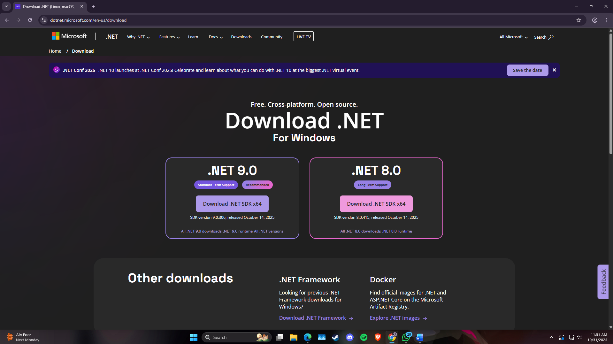

- After download completes, install the .NET SDK with its installer.
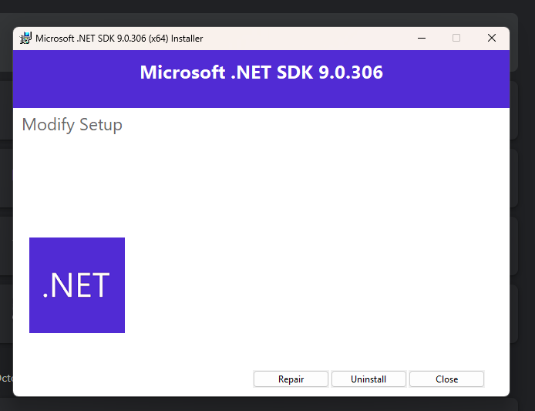
If u already have it installed it will instead show you the uninstall button.
- Open your command prompt to check if the package is installed or not by running ““dotnet --list-sdks”.
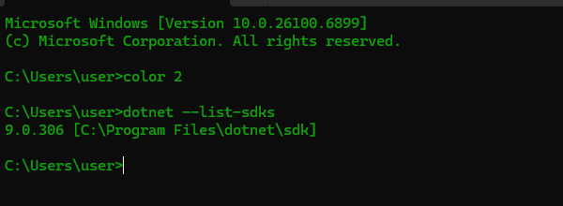
The command prompt should show results similar to the given above image.

  - Visual Studio download and setup
    - Go to website https://visualstudio.microsoft.com/downloads/ and install the community version on your windows.
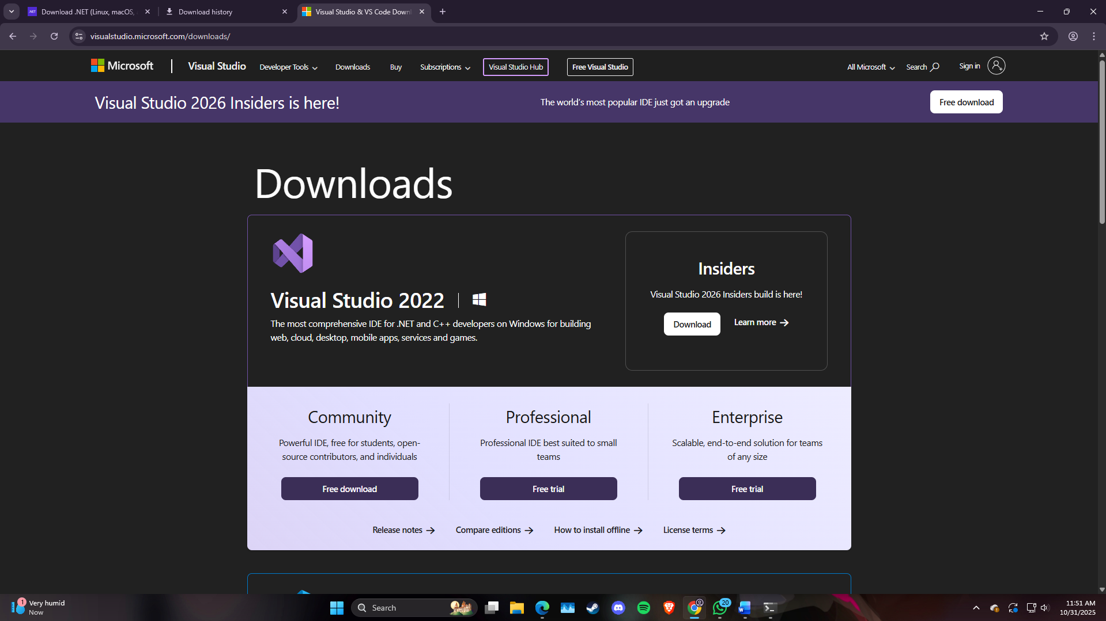
    - Open the VisualStudio setup and select the following packages:
      - . NET Multi-platform App UI development
      - .NET Desktop Development
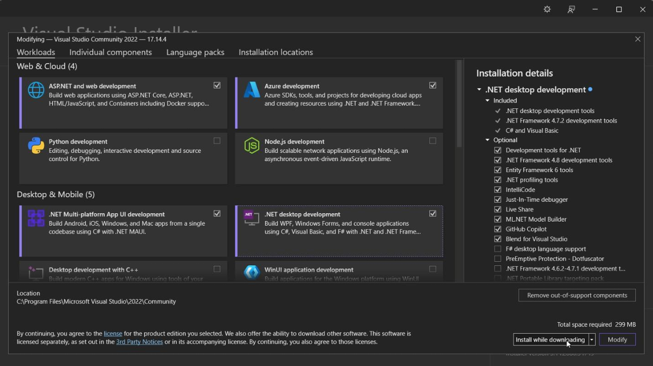

  - Extension for Visual Studio Code (VS Code)
Install the following extension to setup the environment for C#(.net) development:
      - .NET install Tool
      - C#
      - C# Dev Kit
      - IntelliCode for C# Dev kit
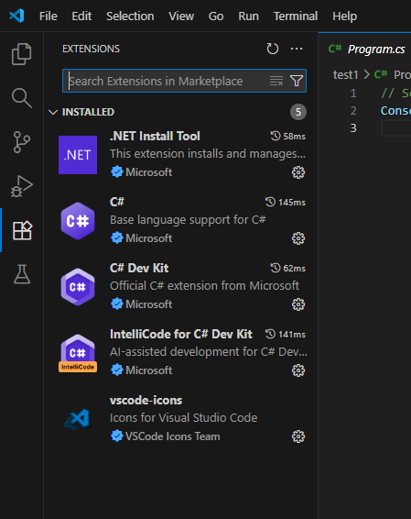

  - Creating a Console App in VS code
    - Now press “ctrl + shift + p” in the command palette and click on “.NET: New Project”.
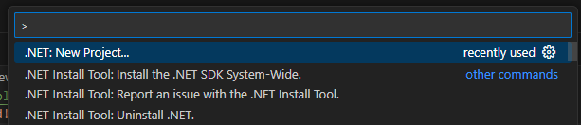
    - Enter “Console App”
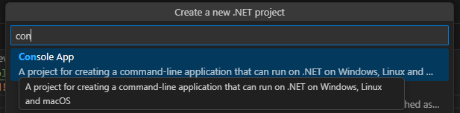
    - Give name to the folder.
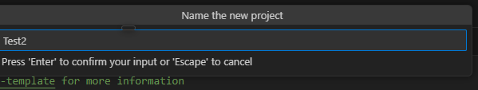
    - Select a directory in which u want to create the project in.
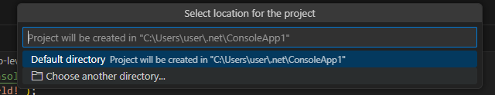
    - Select “sln” solution file format.
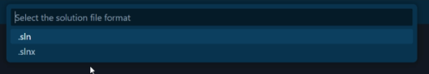
    - Select “create project”. 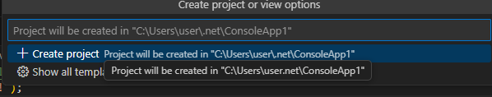
    - Your project is created.
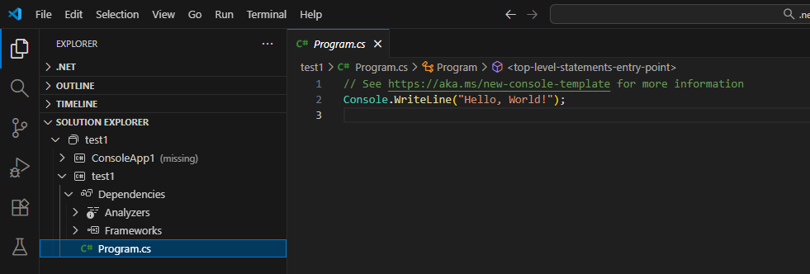
    - Now go to the “Program.cs” file and run the code to check if the output is generated.
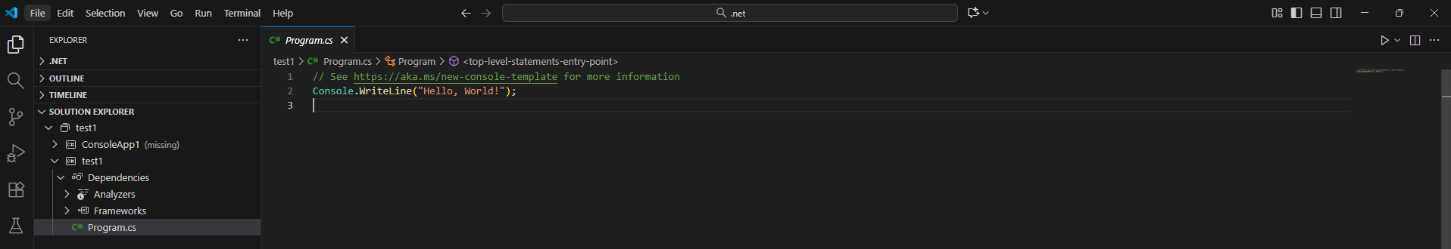
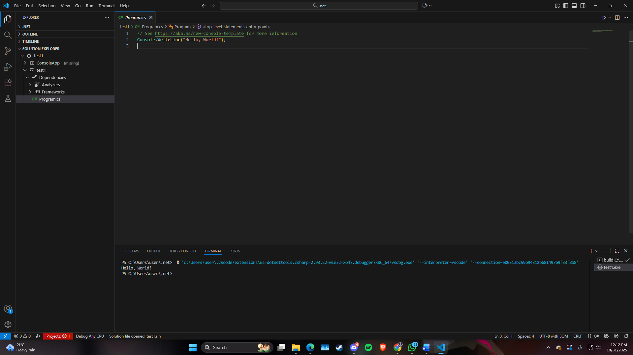
The output is printed “ Hello, World!”.

